Chapter-1

Study of Existing system and system requirements.
Hardware & Software Requirement:

Hardware Interfaces
- Minimum Hardware requirement
- Processor: P4 3.0 GHz
- RAM:1 GB or Higher
- Monitor
- Mouse
- Hard disk: 80 GB

Software Interfaces
- Minimum Software requirement
- Spring Boot & Hibernate
- Logger
- Java (JSP and Servlet)

- Apache Tomcat Server
All these types of software automatic configure inside operating system after installation it having Java, MYSQL, Apache and operating system base configuration file, it doesn’t need to configure manually.
Introduction

Transporting objects from one place to another has become the vital part of our life whether it is some goods or food items. We want our things to be easily shipped to the destination. At the same time, the security of the goods items is necessary. We want our cargo to be delivered safely to the destination.

For this, I have developed Ship Management web application to transport our cargo from one place to another. In our application, we have all the features of adding shipment to tracking them. It is designed to support majorly two roles. One is the Admin who is the main user of this application and another one is the Customer.

I have developed a system where it has functionality of registering users, and allowing them to add shipments. Once the user add the shipment system will generate a unique tracking number which they can keep to keep the track of their shipments. On the hand, Admin who is the main user of this application can view all the shipment list and can immediately update their tracking details time to time.

Users (Customers) and Admin will be able to keep track of their shipment related activity with this application.

Objective

The main objective is to build a secured, robust Ship Management Application. It maintains the record of the shipments, tracking users, tracking shipments history efficiently so that it would be easy to access at any time 24*7.

Each module is built independent of each other. Admin have its own module whereas Customers has its own. Admin responsibility is to view all the registered customers. It can view all the shipments added by the customers. The main role include to update the status of tracking of items from time to time.

Along with this, he can update the cost of shipments by weight. Now, on the other hand, another role we have in this application is that of customers. Customer can register themselves on the application. They can add shipments details like sender name, receiver name, its description, its weight and etc. Along with that in this application, customers have the facility to track their shipment status like whether it is shipped or cancel by the Admin.

Methodologies

There are two main users of this application one is the Admin and another one is the User (Customer) now, let us see the responsibility.
1) Admin
- Admin can manage shipment details in the system.
- Can View/Confirm/Cancel shipments booking.
- Admin can track courier.
- Can manage users and their details.
- Can update cost by weight of the shipment
- Can change password.
- Can manage “My Profiles”.
2) User
- Can log in/log out of the system.
- Can manage “My profile”.
- Can View/Book/Track cargo.
- Can make payments online.
- Can change password.
- Can view cost of shipment by weight

Note: The login, profile section and registration are also present in the system.

Chapter-2
System Analysis
2.1 E R DIAGRAM

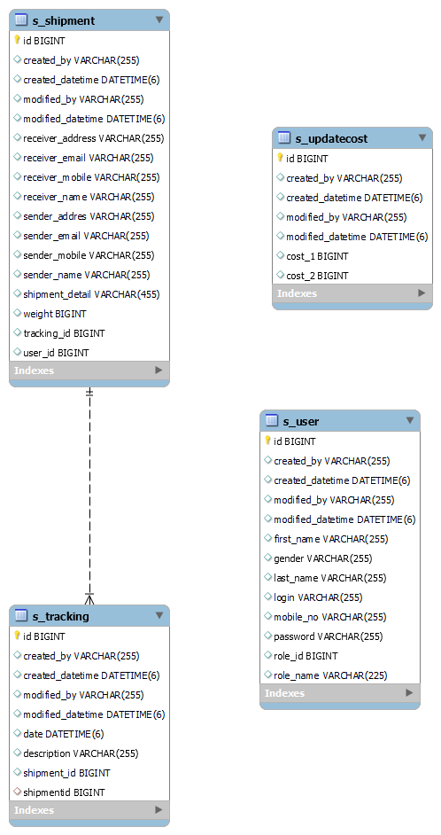

Data Flow Diagram (DFD)
Level 0:
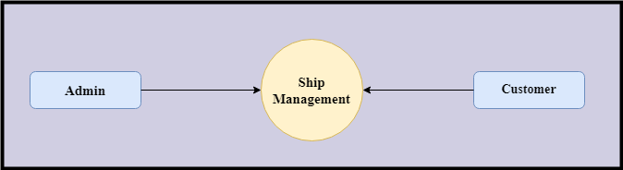

Level 1
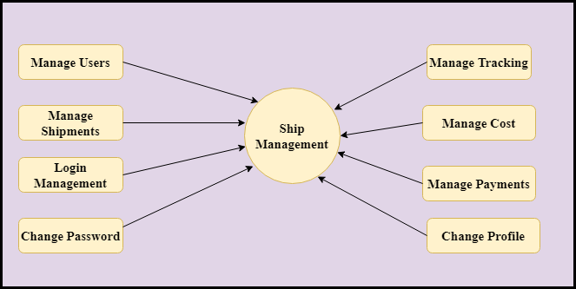

Level 2-DFD Admin
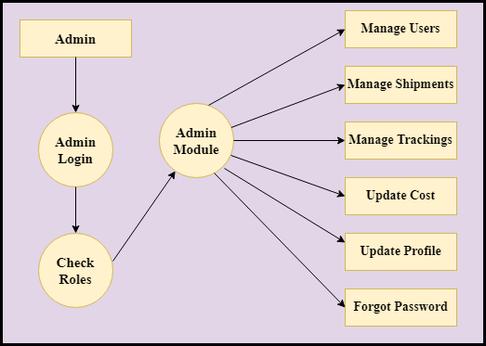
Level 2 DFD – User
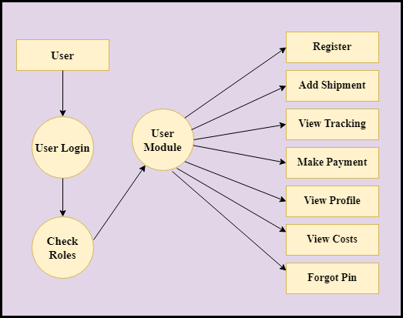
Feasibility:
This project will be developed on computer, so first check whether the technology is technically available or not. Now a day’s computer interaction with any job becomes common for any kind of job or work.

And because of increasing usage of Computer, Computer is also available with a variety of hardware. Vendors can fulfill any type of hardware requirement. The whole project is developed by some special tools or by using languages and databases, which are also available in a variety.

Preliminary investigation of a system examines the feasibility of a system that is useful to an organization. It is the first phase of system development.

The main objective of this phase is to identify the current deficiencies in the user’s environment and to determine which existing problem are going to be solve in proposed system and also which new function needs to be added in proposed system.

An important outcome of such preliminary investigation is to determine whether the system that will meet all needed requirements.

Thus, three tests are carried out on the system namely operation, technical and economical.

Any project is beneficial if and only satisfies the organization requirement. For any new system setup, it only meets to be communicated and work the other supporting system.

The new system meets all existing operations since it provides right information at a right time to the right user. A Leigh man can easily operate with the system.

Technical Feasibility examines whether the technology needed is available and if it is available then it feasible to carry out all project activities.

The technical needs of a system include:

- The facility to produce outputs in a given time.
- Ability to process large number of transaction at a particular speed.
- Giving response to users under certain conditions.

The technology needed for our system is mainly:

- Latest version of browsers.
- Any operating system.

These technologies are available which helps to carry out the system efficiently.

Economical feasibility of a system examines whether the finance is available for implementing the new system and whether the money spent is recoverable the satisfaction.

The cost involves is in designing and developing a good investment for the organization.

Thus, hardware requirements used for proposed system are very standard. Moreover, by making use of proposed system to carry out the work speedily will increase and also saves the valuable time of an organization.

In the proposed system the finance is highly required for the installation of the software’s which can also be recovered by implementing a better system.
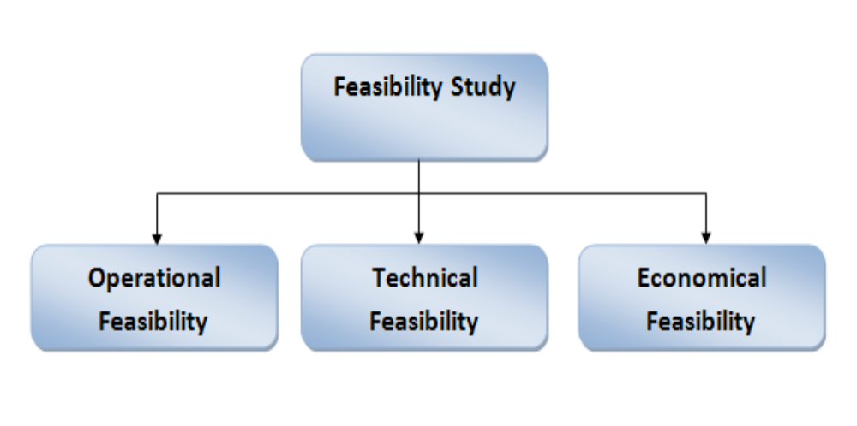

Chapter-3
Design
System Flow Chart:
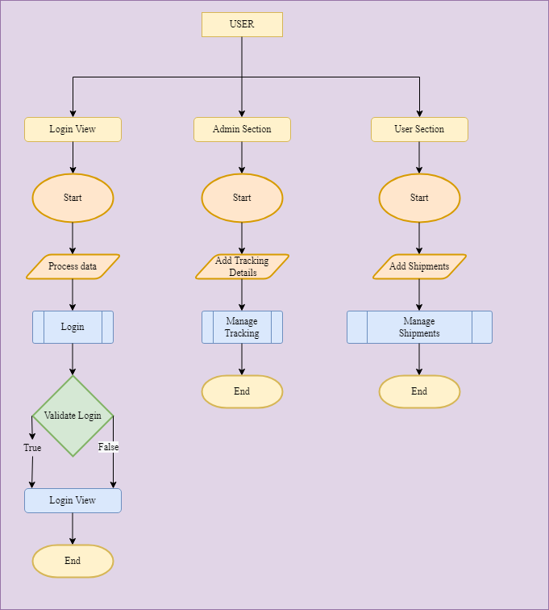

Data dictionary
Data validation:
Procedures are designed to detect errors in data at a lower level of detail. Data validations have been integrated in the system in almost every area where there is a possibility for the user to commit errors. The system will not recognize invalid data.
Whenever an invalid data is keyed in, the system immediately prompts the user and the user has to again key in the data and the system will accept the data only if the data is correct. Validations have been integrated where necessary.
The system is designed to be a user friendly one. In other words the system has been designed to communicate effectively with the user. The system has been designed with pop up menus.

Different Type Of validation:
- Data type validation;
- Range and constraint validation;
- Code and Cross-reference validation; and Structured validation

Coding

Implementation and Testing:
Black-Box Testing:

Black Box Testing, also known as Behavioural Testing, is a software testing method in which the internal structure/ design/ implementation of the item being tested is not known to the tester. These tests can be functional or non-functional, though usually functional.

This can be following way:

- Input interfacing
- Processing
- Output interfacing
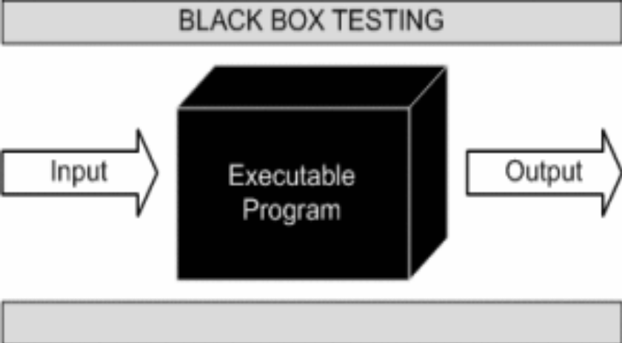

This method is named so because the software program, in the eyes of the tester, is like a black box; inside which one cannot see. This method attempts to find errors in the following categories:

- Incorrect or missing functions

- Interface errors

- Errors in data structures or external database access

- Behaviour or performance errors

- Initialization and termination errors.

White-Box Testing:

White Box Testing ,also known as Clear Box Testing, Open Box Testing, Glass Box Testing, Transparent Box Testing, Code-Based Testing or Structural Testing is a software testing method in which the internal structure/ design/ implementation of the item being tested is known to the tester.

The tester chooses inputs to exercise paths through the code and determines the appropriate outputs. Programming know-how and the implementation knowledge is essential.

White box testing is testing beyond the user interface and into the nitty-gritty of a system.
This method is named so because the software program, in the eyes of the tester, is like a white/ transparent box; inside which one clearly sees.

Limitations and Future Application of the Project

Futures Enhancement:
- In future we can expand this project on the cloud.
- In future, we can send tracking details to User on phone or email.

Limitation :
In this, we don’t have a facility to track add staff user who will take any query generated by the user.

Screen Snapshot
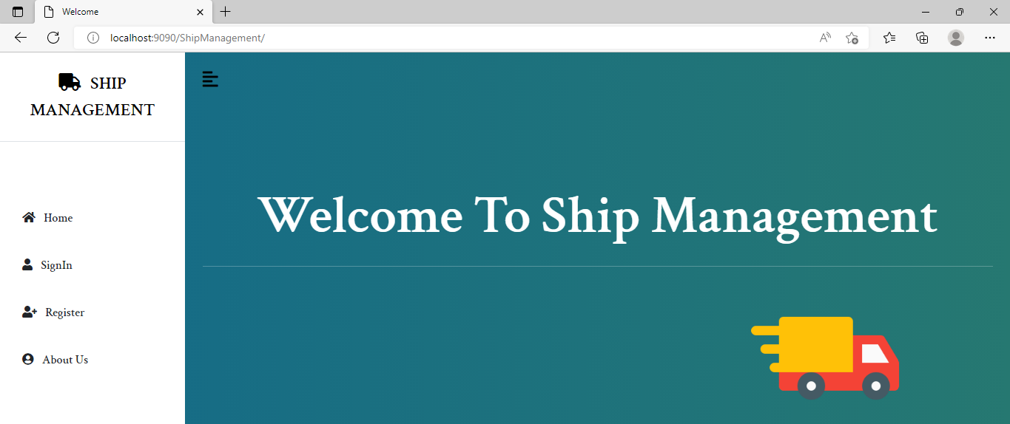
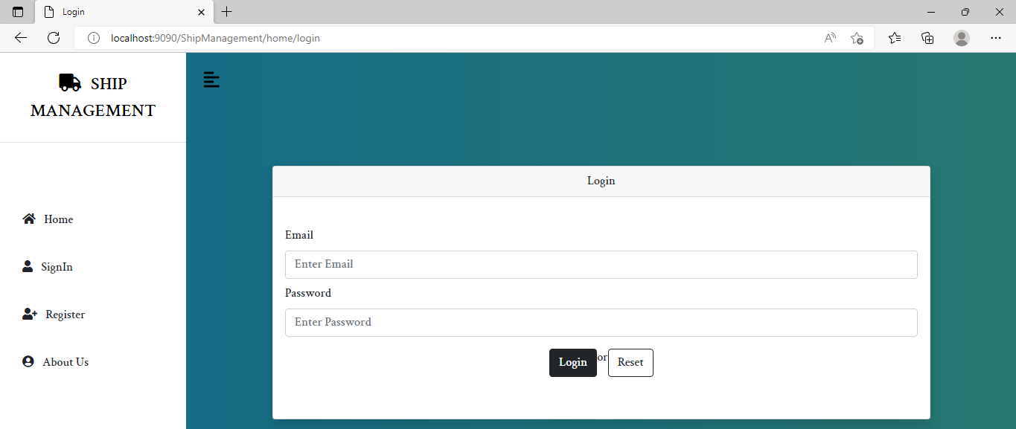
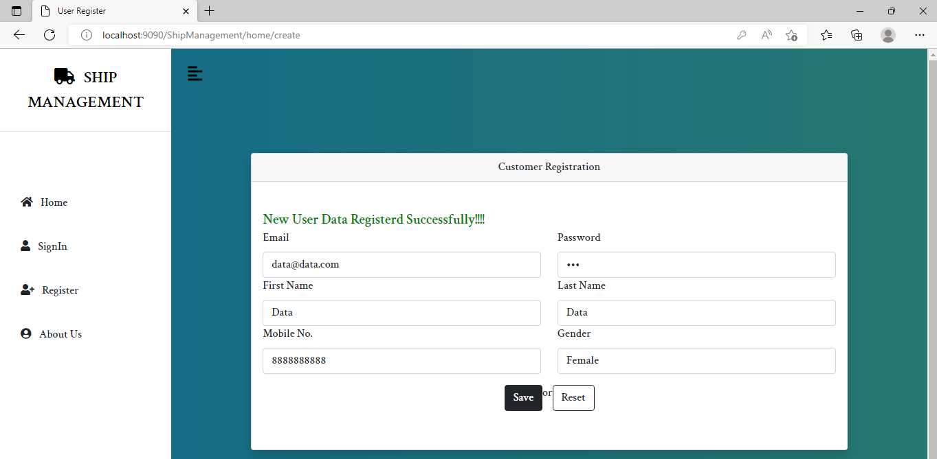
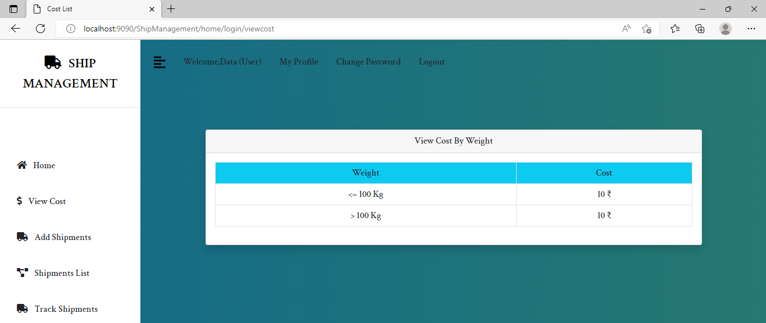
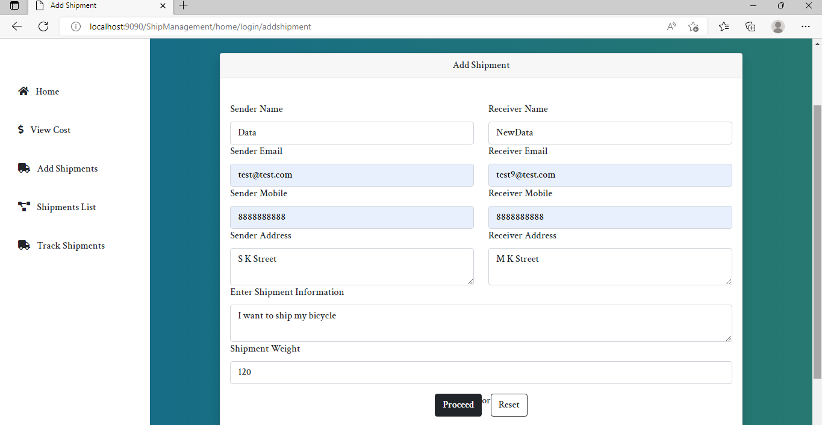
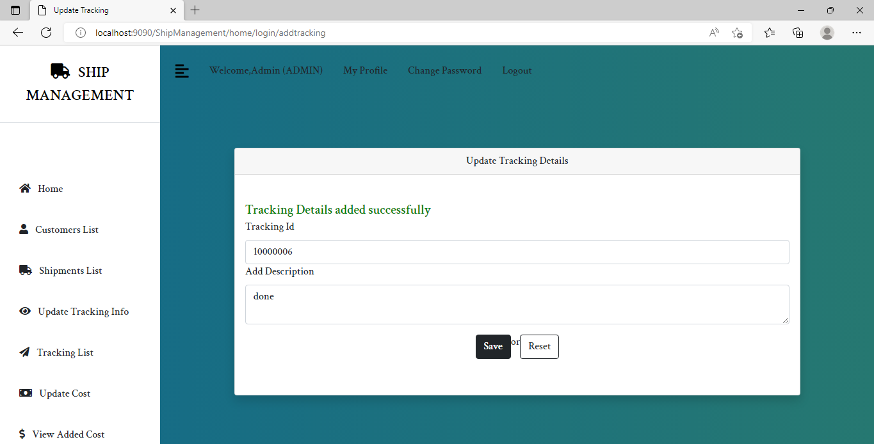

Conclusion

Shipments-related activities can be managed more efficiently using the Ship Management System. Everything will be handled in one place.
On the portal, customers can easily register and make add shipment information. Customers would not need to go to the destination to book shipment and wait in the queue for the payment. Instead they can easily add their shipment details and make payment online. Along with this, they can easily track their courier using the tracking number generated by the system which is unique. Thus, customers can easily book their shipments from one place to another.
This application is designed in such a way that any future modification can be done most easily.

